FOOTBALLS

Rule 1.3.1.g
The ball for 9th grade and above, as in Table 1-3-1, shall include the NFHS Authenticating Mark. The mark can be displayed in either format:
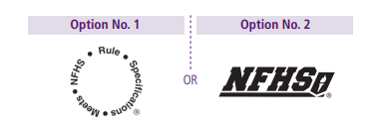

If neither team has approved footballs, Referee will decide on which footballs will be used for that game.
If only 1 team has approved footballs, those are the only balls that should be used for that game.
Any team that does not have approved footballs should be brought to the attention of the Football Commissioner who will then notify applicable school administration.
Referee’s and Umpires need to check and approve footballs before the game

Case Book Ruling/Comment 1.3.2 situation A, B, C, D
This basically states that a team that starts a series with a football (leather or rubber), they must continue with that football throughout the entire series including the try.

I know teams are working to have ball personnel available to provide officials with footballs when one goes out of play, so if that happens, the incoming ball should be the same style football (leather or rubber) that was being used for that series.

The same process should be followed for days where it is raining. If teams need to switch balls (at the discretion of the Referee), they still need to use the same style ball.

The rule is set up to eliminate switching between leather and rubber in the same series and eliminate different footballs for the try (no kicking ball).
Note, the ball may be switched for Free Kick. We still need to ensure that the football is legal and not over-inflated, etc.
COACHES ABILITY TO CHALLENGE A RULE APPLICATON or PENALTY ENFORCEMENT

Rule Book 3.5.2.c
A time-out is requested and granted for the purpose of reviewing a game official’s application of a rule which may have been misapplied or misinterpreted. The time-out remains charged to the requesting team, if no change in the ruling results.

This is for a misinterpreted or misapplied rule which includes penalty enforcement. This review should be completed, if possible, within the 60 seconds allotted for a timeout.

Rule 3.6.2.c notes that any Coach-Referee conference after all permissible charged timeouts for the Coach’s team have been used, and during which the Referee is requested to reconsider the application of a rule and no change in the ruling results, is a penalty for Delay of Game

Case Book 3.5.2 situation A
The captain of A requests a time-out and informs the referee that the coach wishes to have a conference concerning the previous play. During the conference: (a) the captain or all A players go near the sideline to confer with their coaches, or (b) the coach of B goes on the field to the team’s huddle to confer.

Permissible in both (a) and (b). The time-out, when granted, is charged to A, thus legalizing the conferences. If a game official has erred and a correction is made, the conference in both (a) and (b) is terminated. In that case, the time-out is not charged to A, but is an official’s time-out. If the coach is in error, the time-out remains charged to A

Should the ability to challenge rules and penalty enforcement be brought up in pre-game meeting with Referee and Head Coach?

Mechanics for Resetting Play Clock if it is under 25 When Ball Is Set

Case Book 3.6.1 SITUATIONS B, C, D
3.6.1 SITUATION B
The 40-second play clock is running and reads 25 before the ball is ready for play.
The referee shall declare a time-out and signal that the play clock be set at 25 seconds. When play is to be resumed, the referee will give the ready-for-play signal and the play clock shall begin the 25-second count with the game clock also starting if it was previously running.

3.6.1 SITUATION C
When the ball is dead after a running play that ends out of bounds, the 40-second play clock is started. The umpire receives the ball from the line judge, and as he is placing it on the ground, he sees that it is one of Team B’s balls. He tosses the ball to the line judge who attempts to get a Team A ball from the ball boy.
If the play clock reads 25 or less before the correct ball is in from the sideline and ready for play, the referee declares a time-out and signals to reset the play clock to 25 seconds. When the correct ball is ready for play, he signals to start the play clock.

3.6.1 SITUATION D
When the ball is dead after a running play that ends in the side zone, the game officials have difficulty getting the ball in to the hash mark. As the play clock nears 25, the umpire places the ball on the ground, and by the time the game officials are ready, the play clock is below 25 when the umpire steps away.
Without stopping the game clock, the referee gives the “pump” signal to indicate that the play clock is to be reset to 25. If the play clock is reset to 25 without any delay, the game clock does not stop.
Only if the play clock operator does not quickly respond to the referee’s “pump” signal does the referee declare a time-out, signal for the play clock to be set at 25, and then signal to start the game clock and the play clock.
We do NOT want to have the Referee stop the game clock unless absolutely necessary. We should be pumping up the play clock like situation D advises, without stopping the game clock.
Another issue though, is that the Referee may not know what the play clock is at in a 5-man game. In this case, we need the Back Judge to give a pump up the play clock signal to the Referee, who will then mirror that signal so everyone can see.

Mechanics for Ball Being Ready For Play, but Box is Slow to Get to new LOS Spot

Scenario – less than 1 minute left in game or half and the clock is running, Team A is trying to hurry and the ball is set after the previous play, and it is ready for play, but the box is not in position yet.

We should not stop play as this could put one of the teams at a disadvantage. Instead, our Linesman should beanbag the spot that is the new LOS and the down goes off. This will be tough to coordinate and think of, but we need to be ready for this situation.

Same Scenario as above, but the ball is set and it is a new 1st down so the game clock has not restarted yet.

We get a few more seconds to get the Box in position as the game clock is stopped, but we don’t want to be holding things up because of the chain crew. If the chains are in position, but box is still lagging, we can use the beanbag to mark the spot that is the new LOS so we can wind the clock. Again, we don’t want to put a team at a disadvantage by holding things up.

If this happens (especially late in the 1st half), then at the next opportunity (halftime), we need to get with the chain crew and make sure they are capable of keeping up with play. If not, we need to replace them.

Penalty Enforcement Review

Basic Spot for Running Play: END OF THE RUN
Basic Spot for Loose Ball Play: PREVIOUS SPOT

Fouls by the Defense are always enforced from the Basic Spot

Fouls by the Offense ahead of the Basic Spot are enforced from the Basic Spot
Fouls by the Offense behind the Basic Spot are enforced from the Spot of the Foul

Team A, 1st and goal at B10 yard line, A12 throws complete pass to A82 in End Zone for TD; on the play A78 holds B92 at B13 yard line.
Loose Ball play – Basic spot is Previous Spot (B10); Penalty was on the Offense and occurred behind the basic spot; so penalty will be enforced from the spot of the foul. Team A will now have 1st and goal at B23

Team A, 1st and goal at B23, A12 throws incomplete pass to A82 in End Zone; on the play, and before the pass, B45 holds A82 at B18 yard line.
Loose Ball play – Basic spot is Previous Spot (B23); Penalty was on the Defense and occurred ahead of the basic spot; Regardless of penalty occurring ahead or behind the basic spot, the enforcement spot for a Defensive foul is the Basic Spot (or previous spot in this case). Team A will now have 1st and goal at B13
-----------------------------------------------------------------------------------------------------------------------------------------------------------------------
Basic Spot for Post Scrimmage Kick (that crosses the neutral zone) Fouls: END OF THE KICK

Fouls by the Receiving Team that occur ahead of the End of the Kick are enforced from the End of the Kick
Fouls by the Receiving Team that occur behind the End of the Kick are enforced from the Spot of the Foul

Fouls by the Kicking Team (except Kick Catch Interference), are enforced from Previous Spot or from the spot where the dead ball belongs to Receiving Team.

Fouls that occur on the return are part of a Running Play
Free Blocking Zone

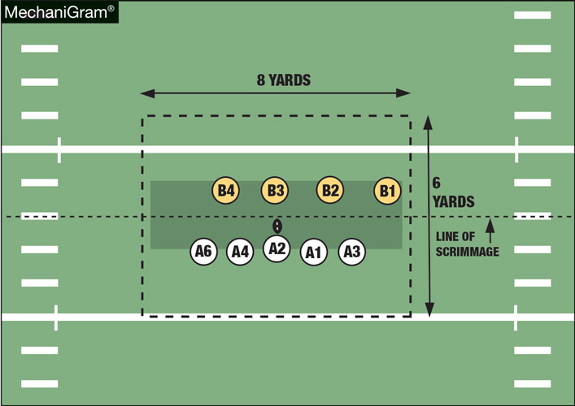

Players are in the zone when any part of their body is in the zone at the snap
Free blocking zone disintegrates once the ball leaves the zone; all low blocks are then illegal

Free Blocking Zone – Blocking Below the Waist

Definition of BBW:
Initial contact from the front or side against an opponent (except the runner) who has one or both feet on the ground

Who can Block Below the Waist and who can be Blocked Below the Waist:
Offensive Players on the LOS and in the zone at the snap
Defensive players who have any part of their body within 1 yard of the LOS and in the zone at the snap

BBW is Legal:
By player on the LOS (as defined above) and in the free blocking zone at the snap against opponents who are on the LOS and in the free blocking zone at the snap

Contact must occur in the free blocking zone and the ball must still be in the free blocking zone

When QB is in Shotgun:
Players may only block low at the snap if they are in a 3 or 4-point stance
Players may only block low on an opponent who is head up
Players may only block low if the block is immediate at the snap

Common BBW Fouls:

- Backs who block defenders low on a sweep play or in pass protection
- Wide outs who block defenders low
- Tackles/TE’s who go out of the zone to block lineman, or linebackers
- Lineman/Backs who block blitzing linebackers low (when LB wasn’t on the LOS at the snap)
- Defensive backs who block low on pulling lineman
- Delayed BBW when QB is in shotgun, or block low from 2-point stance when QB is in shotgun
- After a turnover and the ball is being returned
- Kicks Plays

Free Blocking Zone – Block in the Back

Definition of BBW:
Making initial contact from behind and above the waist against an opponent who is not the runner

Block in Back is Legal:
By player on the LOS and in the free blocking zone at the snap against ANY opponent who is in the free blocking zone at the snap (different wording than BBW)

Contact must occur in the free blocking zone and the ball must still be in the free blocking zone

When QB is in Shotgun:
All BIB’s would most likely be illegal as there wouldn’t be time to execute that type of block before the ball leaves the free blocking zone

Common BIB Fouls:
- Long run plays with aggressive downfield blockers who are behind an opponent
- When QB’s begin to scramble
- Wide sweep plays, lineman late getting outside
- After a turnover and the ball is being returned
- Kick Plays

RULES QUESTIONS

- Replaced player A45 is running toward the sideline but does not get off the field before the ball is snapped. He does not participate in the play. Penalize as Illegal Participation or Illegal Substitution? Live Ball Foul or Dead Ball Foul?

- Following Team K’s kick off from K-40, K21 is the first to touch the ball at the K-46, causing it to roll out of bounds at the K-49. Is there a penalty here? What options does Team R have?

RULES QUESTIONS-ANSWERS

- Replaced player A45 is running toward the sideline but does not get off the field before the ball is snapped. He does not participate in the play. Penalize as Illegal Participation or Illegal Substitution? Live Ball Foul or Dead Ball Foul?
Illegal Substitution (Rule 3.7.4); 5 yards, Live Ball Foul

Dead Ball Illegal Substitution Fouls would be for a Replaced Player not starting to leave the field within 3 seconds
A Replaced Player not leaving to his team’s side of the field
A Substitute or Replaced player coming in and then going off, or going off and then coming back in before the snap, unless there is an accepted penalty, a dead ball foul occurs, there is a charged timeout, or the period ends. (3.7.1; 3.7.2; 3.7.3)

- Following Team K’s kick off from K-40, K21 is the first to touch the ball at the K-46, causing it to roll out of bounds at the K-49. Is there a penalty here? What options does Team R have?

Only Penalty is for Free Kick Out of Bounds
R has standard Free Kick OOB’s options, or the option to take the ball at spot of first touch.
In this play, they will opt for taking the ball at K44 (OOB spot K49 with 5 yards tacked on), or they could push kicking team back 5 yards and have them re-kick.
Receiving Team does not get the option to add 5 yards to the spot of 1st touch.

